Unifrog: The Complete Online Careers Platform
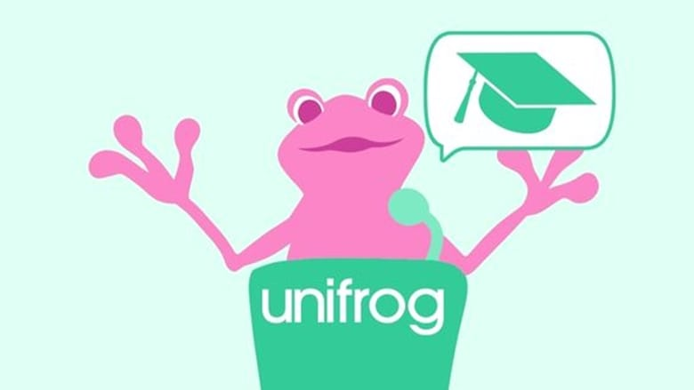
iCollege is excited to announce that we are using Unifrog across our Service! In keeping with our commitment to provide students with outstanding careers guidance and tailored support when choosing their next steps after iCollege, we have subscribed to Unifrog - an award-winning, online careers platform.

All students in Years 7, 8, 9, 10, 11 and Post 16 can have access to this excellent website!
It is now available for Primary learners too with an extensive library of career sector profiles; featuring video, engaging text, fun images, and accessible Labour Market Information.

The Unifrog platform is designed to support learners in finding out about the vast selection of college courses and employment choices open to them and how these link to personal areas of interest and preferred subjects at school. Young people can then make the most informed decisions about their futures; Unifrog also offers a range of tools that are suitable for all year groups.

Each learner will have their own personal account that provides a wide range of information related to their interests and aspirations. Parents are also encouraged to sign up for and access Unifrog accounts. Key features of the platform include:
- Exploring Pathways – personality quizzes, career and subject profiles.
- Film clips and recordings about extracurricular activities and key employability skills.
- Search tools showing live vacancies for apprenticeships, college courses and work experience,
- Applications tools to help young people build applications for a range of pathways
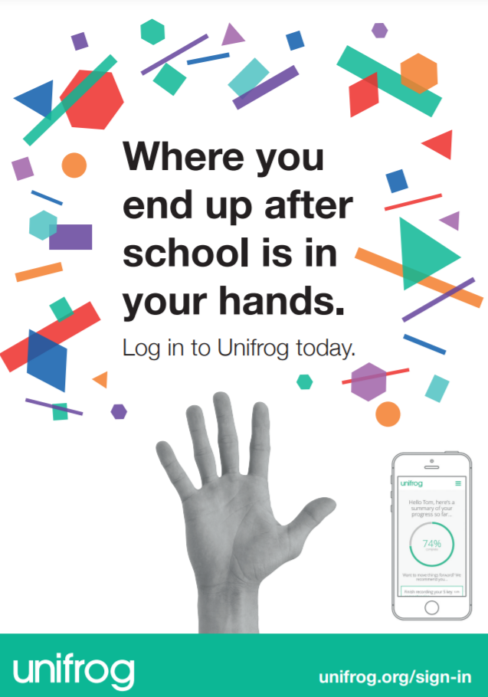
Staff are trained to ensure learners at iCollege are well supported to access all aspects of Unifrog. Young people across the Service are encouraged to create accounts, explore personality quizzes and research careers at school or at home. Interactions can be added to their profile which provides excellent evidence in support of CVs and applications for jobs and courses. provide evidence as they build CVs and apply for jobs and courses.

Learners login to Unifrog using their email address and password and they can do so from any computer, tablet or smartphone. We would encourage parents and carers to use the platform with their children and young people. Parent logins are available which allows parents to support the process at home.
Please contact Ali Haynes on 07464895993 or ahaynes@icollege.org.uk to request a log in or for more information.




