iCollege Careers Programme achieves 100% against Gatsby Benchmarks!

The Careers programme for iCollege is based on recommendations by the Careers Development Institute (CDI) and is underpinned by the eight Gatsby Benchmarks.

We are delighted to share that iCollege scored 100% in their Gatsby Benchmark evaluation in December ’23 as evidenced by the Careers & Enterprise Company.
The illustration below shows the Careers areas we are monitored on every term. 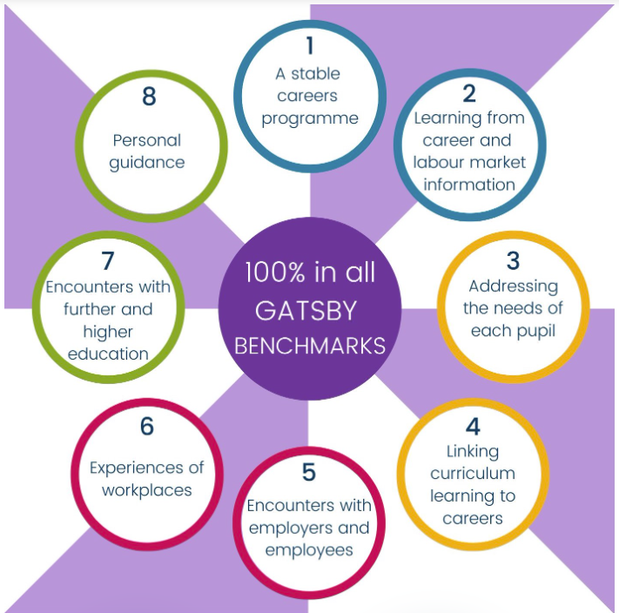

Many thanks to staff, students, parents, employers, offsite providers and our links with Further and Higher Education – collaborative working has made this achievement possible!

This graph shows your latest evaluation results along with your progress and how your plans are impacting your Compass score.
iCollege Alternative Provision
Report generated on December 3rd 2023 at 16:44
© The Careers and Enterprise Company 2023. All rights reserved.
Gatsby Benchmark Latest Evaluation | Total achievement
1-A stable careers programme | 100%
  100%
2-Learning from career and labour market information | 100%
  100%
3-Addressing the needs of each pupil | 100%
  100%
4-Linking curriculum learning to careers | 100%
  100%
5-Encounters with employers and employees | 100%
  100%
6-Experiences of workplaces | 100%
  100%
7-Encounters with further and higher education | 100%
  100%
8-Personal guidance | 100%
  100%
Reached 1% - 99% Reached 100%

